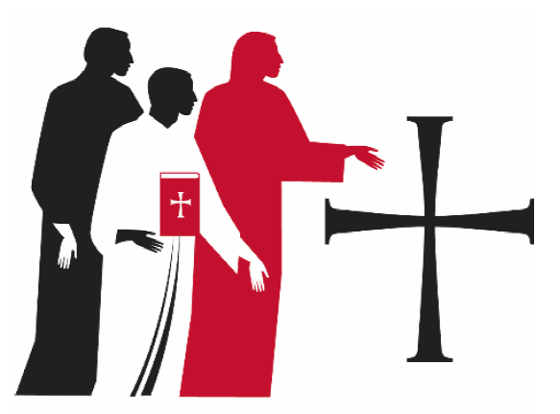

Affirmation of Ministers of Word and Service

Because all of its baptized members share in Christ’s ministry of love and service, the church equips and supports them for their ministries in the world. Within this context of ministry, the church calls some of its baptized members for specific ministries.

The ministry of word and service has New Testament roots in the ministry of diakonia: Stephen, Philip, and five others oversee the distribution of food within the church in Jerusalem; Phoebe and Priscilla are identified with diakonia in Paul’s letters. Although this ministry has taken different forms throughout the church’s history, its emphasis has been this: Those called to the ministry of word and service speak God’s word to God’s world, and in turn they speak also for the needs of God’s world to the church; they give leadership in the church’s mission to witness to God’s love through both words and actions.

Affirmation of Ministers of Word and Service is intended for optional use with those who have previously been consecrated or commissioned as deacons, deaconesses, diaconal ministers, and associates in ministry within the Evangelical Lutheran Church in America or its predecessor church bodies, and who, by action of the 2016 Churchwide Assembly, are included in a single, unified roster as ministers of word and service, also known as deacons. Following the 2019 Churchwide Assembly, deacons are ordained to the ministry of word and service.

Affirmation of Ministers of Word and Service may be set within the service of Holy Communion, following the sermon and the hymn of the day. The Nicene Creed or Apostles’ Creed may precede this rite. The rite may be used to acknowledge one or more deacons within a synodical gathering, as part of a regularly scheduled service of a congregation, or within a specific service for this purpose.

Presentation
The presiding minister invites the minister/s of word and service to come before the assembly. The assembly is seated.

The presiding minister addresses the assembly.
Today we recognize name/s,
minister/s of word and service in the Evangelical Lutheran Church in America.
Having been called to the ministry of word and service,
having been consecrated or commissioned to this ministry,
we affirm that they are included on the roster of those ordained as ministers of word and service.

Address and Questions
The presiding minister addresses the minister/s of word and service.
All baptized Christians are called to share
in Christ’s ministry of love and service in the world,
to the glory of God and for the sake of the human family and the whole creation.
You have been called as minister/s of word and service
to give leadership in the church’s mission
to proclaim the gospel through word and deed.
You have been entrusted with the ministry of word and service
in the one holy catholic church
by the laying on of hands and by prayer.

One or more of the following scripture passages are addressed to the minister/s of word and service.
A reading from Luke: Jesus said, “The Spirit of the Lord is upon me, because he has anointed me to bring good news to the poor. He has sent me to proclaim release to the captives and recovery of sight to the blind, to let the oppressed go free, to proclaim the year of the Lord’s favor.”
(Luke 4:18-19)

A reading from First Corinthians: There are varieties of gifts, but the same Spirit; and there are varieties of services, but the same Lord; and there are varieties of activities, but it is the same God who activates all of them in everyone. To each is given the manifestation of the Spirit for the common good. (1 Corinthians 12:4-7)

A reading from Second Timothy: Rekindle the gift of God that is within you through the laying on of hands. Hold to the standard of sound teaching that you have heard, in the faith and love that are in Christ Jesus. Guard the good treasure entrusted to you, with the help of the Holy Spirit living in us. Be strong in the grace that is in Christ Jesus. (2 Timothy 1:6, 13-14; 2:1)

The presiding minister addresses the minister/s of word and service.
Before almighty God, to whom you must give account,
and in the presence of this assembly, I ask:
Will you continue to accept this ministry, believing that you are called by God
to serve faithfully as minister/s of word and service?
Response: I will, and I ask God to help me.

The Evangelical Lutheran Church in America confesses
that the holy scriptures are the word of God and are the norm of its faith and life.
We accept, teach, and confess the Apostles’, the Nicene, and the Athanasian Creeds.
We also acknowledge the Lutheran confessions
as true witnesses and faithful expositions of the holy scriptures.
Will you therefore continue to serve in accordance with the holy scriptures
and these creeds and confessions?
Response: I will, and I ask God to help me.

Will you continue to be diligent in your study of the holy scriptures
and faithful in your use of the means of grace?
Will you pray for God’s people,
encourage and support them as they worship and grow in faith,
and lead them by your own example in faithful service and holy living?
Response: I will, and I ask God to help me.

Will you give faithful witness in the world through word and deed,
that God’s love may be known in all that you do?
Response: I will, and I ask God to help me.

Almighty God, who has given you the will to do these things,
graciously give you the strength and compassion to perform them.
The assembly responds: Amen.

The assembly stands.

Acclamation by the Assembly
The minister/s of word and service face the assembly. The presiding minister addresses the assembly.
Will you, assembled as the people of God,
continue to receive name/s as minister/s of word and service,
sent by God to serve all people in Christ’s name?
We will, and we ask God to help us.

Will you pray for them,
help and honor them for their work’s sake,
and in all things strive to live together in the peace and unity of Christ?
We will, and we ask God to help us.

Charge
The presiding minister addresses the minister/s of word and service.
Name/s,
continue to care for God’s people, bear their burdens,
and do not betray their confidence.
Serve the needy, care for the sick, comfort the distressed,
and, through words and actions, witness faithfully to God’s love for all people.
Cross every barrier that stands between the church and its ministry in the world.
Seek out those places where the gospel of Jesus Christ meets the world’s need.
Empower, equip, and support all the baptized in the ministry of Jesus Christ.
Lead us all in proclaiming the gospel
in word and song, in witness and service.
And be of good courage, for God has called you,
and your labor in the Lord is not in vain.

Giving of a Stole
If a deacon’s stole was not given at a particular deacon’s entrance rite, it may be placed over the deacon’s shoulder as the presiding minister says:
Receive this stole as a sign of your work, and live in obedience to the Lord Jesus, serving his people and remembering his promise: “Come to me, all you that are weary and are carrying heavy burdens, and I will give you rest. Take my yoke upon you, and learn from me; for I am gentle and humble in heart, and you will find rest for your souls. For my yoke is easy, and my burden is light.” (Matthew 11:28-30)

Blessing
The presiding minister continues.
The God of peace, who brought again from the dead our Lord Jesus,
the great shepherd of the sheep, by the blood of the eternal covenant,
make you complete in everything good so that you may do God’s will,
working in you that which is pleasing in God’s sight;
through Jesus Christ, to whom be the glory forever and ever.
Amen.

The minister/s of word and service face the assembly. The presiding minister addresses the assembly.
Let it be acclaimed that name/s
are ministers of word and service in the church of Christ,
together with all who are set apart and ordained to this ministry:
deacons who are called to serve among God’s people
as together we bear God’s creative and redeeming love to all the world.
Amen. Thanks be to God.

The service continues with the prayers of intercession. Prayers are included for those who have been called to the ministry of word and service, all ministries in the church, and all Christians in their vocations.

