FAIR TRADE

Selective Purchasing Policy Guide
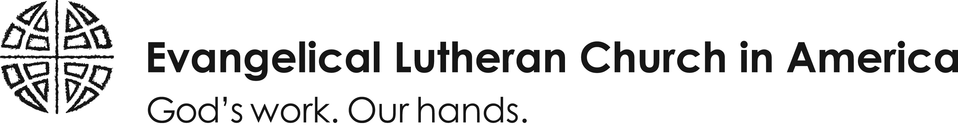

Issue Description: Lutherans are known for their involvement in purchasing fair trade coffee and other commodities which also support Lutheran World Relief in the process. Early on, the value of supporting community-based co-ops where fair wages, women and children’s and indigenous rights, the right to organize, and environmental stewardship is promoted, was recognized.
The fair trade movement has gone well beyond the original coffee issue. However, not all locally produced or environmentally-sound products are certified as fair trade. Today, in the US, Transfair is the certifying body for the majority of products sold under the fair trade banner http://www.transfairusa.org/.
Sample wording: “XXX (synod/congregation/organization) chooses to support fair trade alternatives. Therefore, all of our x, y, & z will be purchased from fair trade sources and be clearly marked with a fair trade certification label (e.g. coffee, tea, sugar, hot cocoa, crafts, and other items).
Resources:
Lutheran World Relief - http://www.lwr.org/fairtrade/index.asp
The Buying game http://www.thebuyinggame.org/
Examples:
McMaster’s University Policy - http://www.mcmaster.ca/policy/fairtrade.pdf
Where to buy:
Lutheran World Relief - http://www.lwrcoffee.com/
Transfair purchasing locator guide - http://www.transfairusa.org/content/WhereToBuy/
A greater gift - http://www.serrv.org/
Ten Thousand Villages – http://www.tenthousandvillages.com

