Mission of the Month

**Stories from the global church spring 2014**

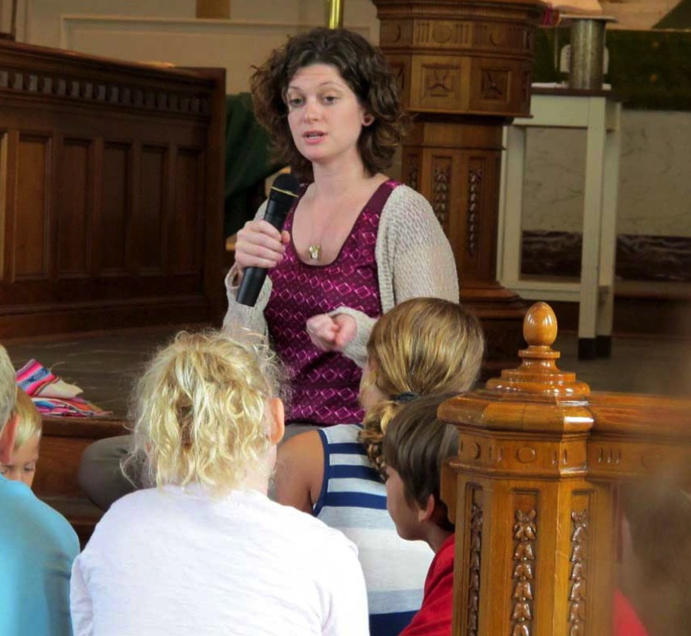

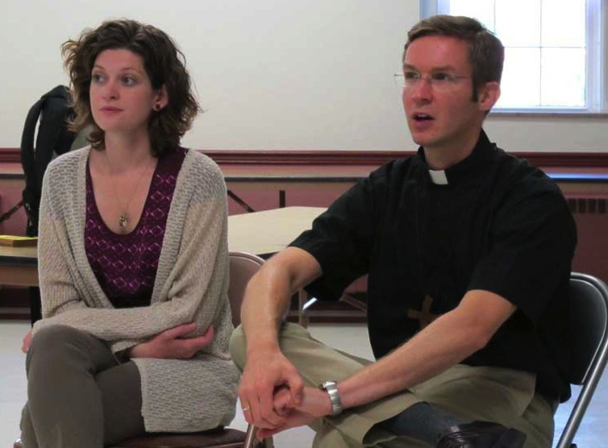

**Supporting Sunday schools   
in Bolivia**

**After hearing many times that there was a need for Lutheran materials in the Bolivian Evangelical Lutheran Church**, Kari Eller decided to involve her husband, Justin, and others to create inexpensive, accessible Sunday school materials that could be used by a variety of teachers. With the help of the ELCA’s Equipping God’s People Project, the Ellers were able to coordinate and create a Sunday school book.

“We share the book with a pay-it-forward mentality in hopes that other Spanish-speaking Lutherans around the world who create Christian education materials, whether they are for Sunday school, workshops, confirmation, etc., will want to do the same and share their resources with others as well,” Kari says.

Creating the Spanish language book was a year-long process. The finished project can be downloaded online for free, but because computers are not available everywhere in Bolivia and other Spanish-speaking countries, a print edition is also published. Five hundred copies are printed and distributed each year.

“I can’t tell you how proud I am of all of the contributors and the excellent work they did to make this book a possibility,” says Kari.

The book has made it possible for a congregation with little or no funds to have teaching materials, because not only is it free, but it doesn’t require you to have anything other than the Bible and other basic items that most congregations have available. It also allows Sunday school teachers to personalize the lessons according to the group’s needs and interests.

Often, teachers, who are usually high school or college students, take turns teaching classes because they cannot commit to a full year. The hope is that even with changing teachers and activities, the students will still be able to hear the gospel of Christ, which is of critical importance to Lutheran Christians.

While the Ellers have recently moved to a new assignment in Buenos Aires, Argentina, the generous support of ELCA members enables them and over 240 other ELCA missionaries in the global church to continue their ministry.

**Get involved!**

*Learn more:* [*search.ELCA.org/pages/ourwork/bolivia.aspx*](http://www.search.ELCA.org/pages/ourwork/bolivia.aspx) *and* [*ELCA.org/missionarysponsorship*](http://www.ELCA.org/missionarysponsorship)

*Make a gift to support their ministry:* [*https://community.ELCA.org/bolivia*](https://community.ELCA.org/bolivia)

**bolivia   
LEFT:** *Kari and   
Sunday school students discussing   
the day’s lessons.***BELOW:** *Kari and the   
Rev. Justin Eller, missionaries.*